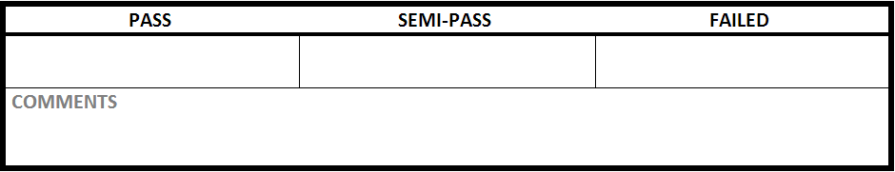

|  |  |
| --- | --- |
| Test Case #:ITM1.2 | Test Case Name: Create Item |
| System: Rec Warehouse | Subsystem:Item |
| Designed by: Rec Team | Design Date: October 2013 |
| Executed by: | Execution Date: |

|  |
| --- |
| Short Description:Create a item with no data |

|  |
| --- |
| Preconditions:at the main page |

|  |  |  |  |  |
| --- | --- | --- | --- | --- |
| Step | Action | Expected System Response | Pass/Fail | Comment |
| 1 | click ‘Item Management" | changes to the create item screen | Pass |  |
| 2 | click Create New Item | check postcondition 1 | Pass |  |

|  |
| --- |
| Postconditions:  1. does not creates a item in the database and displays an error message for no Vendor Name,Product Line, Vendor Item, Item Name, Description, Department, Category, Sub-category, Regular Selling Price. |